1)
- Prior to birth, millions of oogonia develop in the ovaries.
- Diploid number of chromosomes (2n)
- Divide by mitosis.
2)
- By birth, oogonia have undergone growth phase to become primary oocytes (400,000).
- Begins prophase stage of meiosis 1 but arrests at this stage (chromosomes coil, become visible, homologous pairs form, crossing-over).
- Surrounded by single layer of cells forming primary follicle.
3)
- At puberty, follicle growth and maturation occurs.
- Primary oocyte completes meiosis 1, producing two daughter haploid (n) cells, unequal in size.
- Secondary oocyte - Contains haploid n chromosomes and almost all of cytoplasm
- First polar body - Contains haploid n chromosomes but little cytoplasm. May undergo meiosis 2 to produce 2 polar bodies but all eventually disintegrate.
4)
- Secondary oocyte commences meiosis 2 but stops at metaphase 2.
- Ovulation occurs – follicle ruptures, secondary oocyte and its polar body is expelled and enters uterine tube.
- If fertilization occurs, meiosis 2 completes. Produce 2 cells of unequal size – smaller cell (second polar body) and larger cell (ovum).
- Nuclei of ovum and sperm fuse, forming diploid zygote (2n). Develops into embryo.

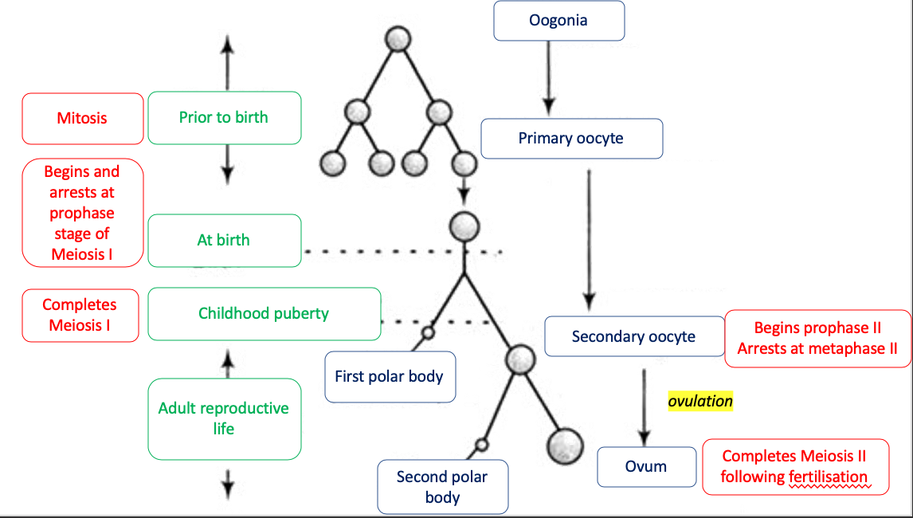

Spermatogenesis |  | Oogenesis
Puberty | When does it begin? | Prior to birth
Ongoing from puberty | When does Meiosis I occur? | From puberty (arrests at metaphase 2)
Ongoing from puberty | When does Meiosis II occur? | From fertilisation
Ongoing until old age | When does it end? | Ongoing until menopause
From 1x spermatogonium  8x spermatozoa, haploid (n), head-midpiece-tail, motile | Products  (name, quantity, # of chromosomes, shape, motility) | From 1x oogonium  2x ova, haploid (n), round cell, non-motile

